AI ASSISTANT APP

PROBLEM STATEMENT:
In today’s digital era, users expect faster, smarter, and more natural ways to interact with mobile applications. Traditional applications rely heavily on text-based input, which can be time-consuming and less convenient, especially in situations where typing is difficult or inefficient.
Although AI-powered assistants exist, many mobile applications lack a seamless integration of both text and voice-based interaction within a simple and user-friendly interface. This creates a gap in providing an intuitive and accessible user experience.
The problem is to design and develop an AI-powered mobile assistant application that:
- Supports both text and voice input for user interaction
- Provides real-time intelligent responses using an AI API
- Ensures smooth and efficient performance through proper state management
- Offers a clean and interactive chat interface
- Provides secure user authentication
The system should be capable of capturing user input through voice or text, converting speech to text, processing it through an AI service, and delivering accurate responses in real time.

ABSTRACT
The rapid advancement of artificial intelligence and mobile technologies has transformed the way users interact with applications. This project presents the design and development of an AI-powered assistant mobile application using Flutter, which enables users to interact through both text and voice-based input.
The application provides a real-time chat interface where users can enter queries either by typing or using a microphone feature. The voice input is converted into text using speech recognition, which is then processed through an external AI API to generate meaningful and intelligent responses. The system ensures smooth and dynamic user interaction by implementing efficient state management using the Provider framework.
The application follows a modular architecture consisting of presentation, state management, service, and data layers, ensuring scalability and maintainability. Additionally, Firebase is integrated to provide secure user authentication and session management.
By combining AI capabilities with voice-enabled interaction, the system enhances accessibility, improves user convenience, and offers a more natural way of communication. This project demonstrates the effective integration of modern technologies to build an intelligent, responsive, and user-friendly assistant application with potential for future enhancements such as multilingual support and personalized responses.

TECHNOLOGIES USED
The AI Assistant mobile application is developed using modern tools and frameworks to ensure performance, scalability, and an enhanced user experience with both text and voice interaction.
1. Flutter
Flutter is an open-source UI toolkit developed by Google.
- Used to build the mobile application
- Provides rich UI components
- Supports cross-platform development
2. Dart
Dart is the programming language used by Flutter for building fast and efficient applications.
- Used for writing application logic
- Supports asynchronous programming
- Helps in building responsive and dynamic UI
3. Provider (State Management)
Provider is a lightweight state management solution used in Flutter.
- Manages application state efficiently
- Updates UI dynamically when data changes
- Simplifies data flow between components
4. REST API Integration
The application communicates with an external AI service using REST APIs.
- Sends user input to the AI server
- Receives and processes responses in JSON format
- Enables real-time conversational functionality
5. HTTP Package
Flutter’s HTTP package is used to handle network requests.
- Performs POST requests to the API
- Handles API responses and error management
- Supports asynchronous communication
6. Speech-to-Text (Voice Input)
- Enables voice-based interaction using microphone
- Converts user speech into text
- Improves accessibility and user convenience
- Integrated using Flutter speech recognition packages
7. Firebase (Authentication & Backend Services)
Firebase, developed by Google, is used for backend support.
- User authentication (Login/Register)
- Secure user session management
- Scalable cloud-based backend
8. Android Studio / VS Code
Development tools used for building and testing the application.
- Code editing and debugging
- Emulator support for testing
- Plugin support for Flutter development
9. Git & GitHub
Version control and code hosting platform.
- Tracks code changes
- Enables collaboration
- Stores project repository online
METHODOLOGY
The development of the AI Assistant mobile application follows a structured approach combining mobile app development, API integration, and voice-enabled interaction to deliver a smooth and intelligent user experience.
1. Requirement Analysis
In this phase, the system requirements were identified and analyzed.
- Real-time AI-based assistant
- Support for both text and voice input
- User-friendly chat interface
- Secure authentication system
- Efficient state management
This step ensured a clear understanding of the problem and defined the project scope.
2. System Design
The system was designed using a modular architecture to separate concerns and improve maintainability.
- UI Layer (Screens & Widgets)
- State Management Layer (Provider)
- Service Layer (API handling)
- Data Layer (Models)
The design ensures smooth communication between components and scalability for future enhancements.
3. UI/UX Development
The user interface was developed using Flutter to provide an interactive experience.
- Chat interface with message bubbles
- Text input field and microphone button for voice input
- Smooth navigation (Login, Home, Chat screens)
- Responsive and clean design
The focus was on simplicity, readability, and user engagement.
4. Voice Input Integration (Speech-to-Text)
A microphone feature was implemented to enhance usability.
- Captures user speech through the device microphone
- Converts speech into text using speech recognition
- Automatically fills the input field with converted text
This enables natural and hands-free interaction.
5. API Integration
The application integrates with an external AI service using REST APIs.
- User messages are sent to the API via HTTP requests
- The API processes the input and generates a response
- Responses are received in JSON format and displayed to the user
This enables real-time conversational functionality.
5. State Management Implementation
Provider was used to manage application state efficiently.
- Stores chat messages
- Updates UI dynamically when new messages arrive
- Handles loading and response states
This ensures smooth performance and organized data flow.
6. Authentication System
Firebase Authentication was implemented to manage user access.
- User registration and login functionality
- Secure session handling
- Persistent authentication state
This ensures that only authorized users can access the application.
7. Testing and Debugging
The application was tested to ensure functionality and performance.
- Debugging using Flutter tools
- Testing API responses and error handling
- Fixing build and device connection issues
This phase ensured reliability and stability of the application.
8. Deployment
The final application was built and deployed on an Android device.
- APK generation using Flutter
- Testing on real device
- Preparing project for GitHub submission

SYSTEM ARCHITECTURE
The system follows a layered architecture where UI interacts with Provider for state management, which communicates with the API service to fetch AI responses and update the interface dynamically.
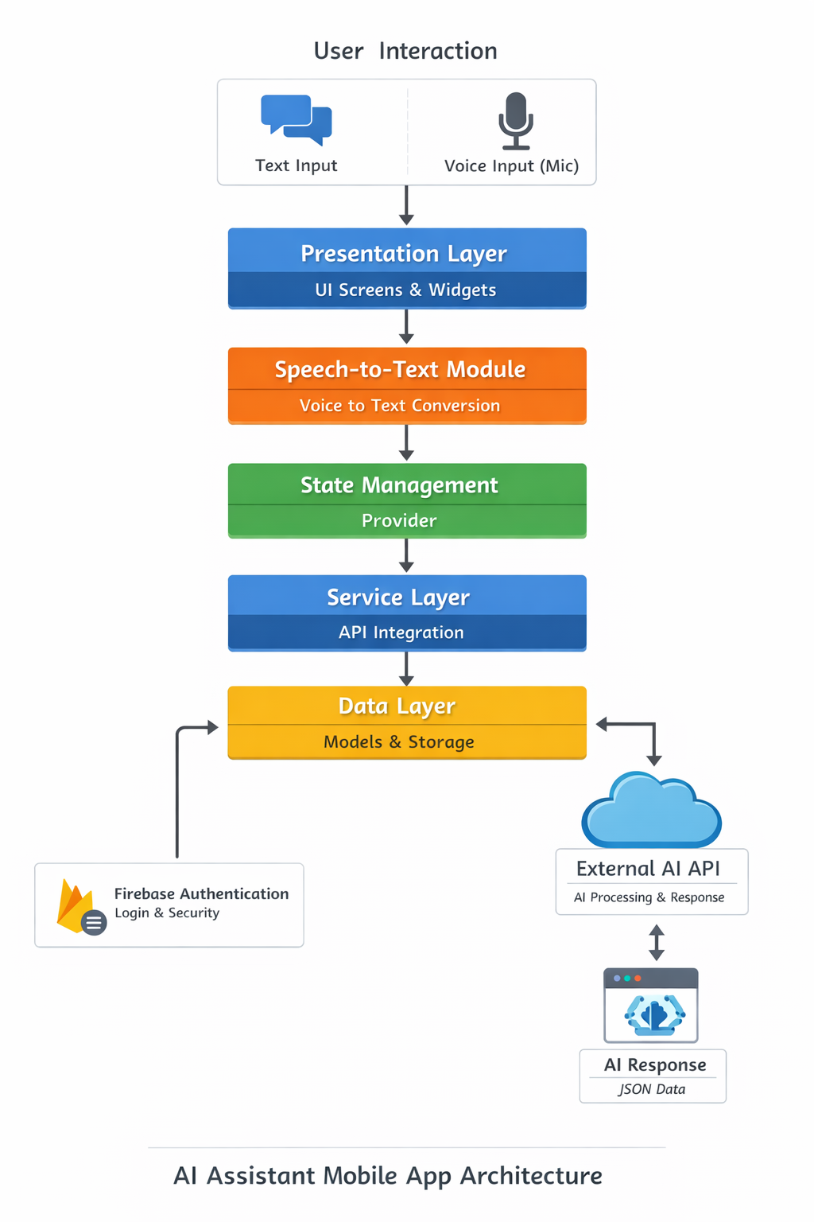

APP FLOW
The API flow describes how user messages are processed and how responses are generated in the AI Assistant application.
- The user enters a message in the chat interface.
- The message is sent to the Chat Provider, which manages the app state.
- The provider forwards the message to the API Service.
- The API Service sends an HTTP request to the external AI API.
- The AI API processes the request and generates a response.
- The response is returned in JSON format to the API Service.
- The provider updates the message list with the AI response.
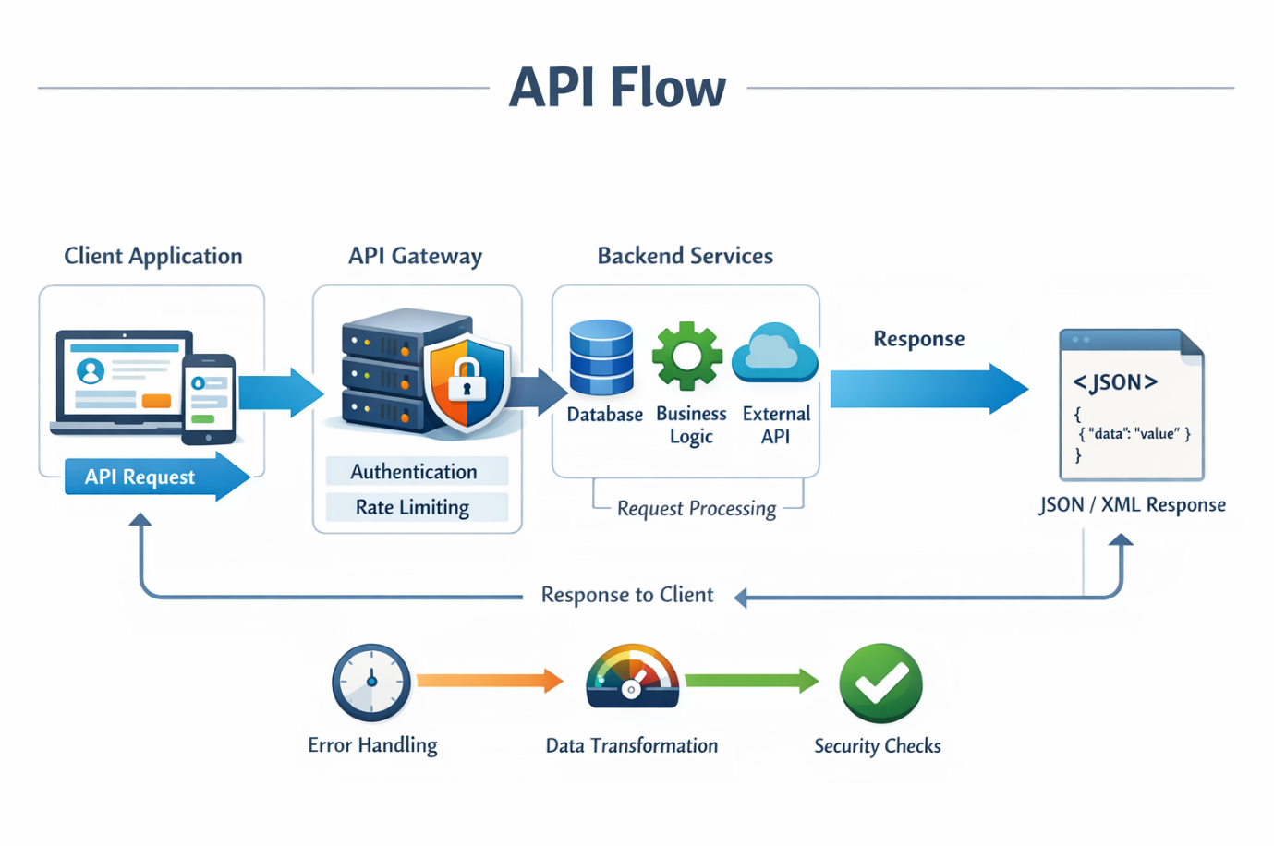
- The updated response is displayed in the chat UI.

STATE MANAGEMENT
The diagram shows how state is managed in the AI Assistant app using the Provider pattern, along with the added voice (mic) feature.
When the user gives input through text or voice, the voice input is first processed by the Speech-to-Text module, which converts it into text. This input is then sent to the Chat Provider, which manages the message state and application logic.
The provider forwards the request to the API Service, which communicates with the AI API to fetch a response. Once the response is received, the provider updates the state and notifies the UI to display the AI response.

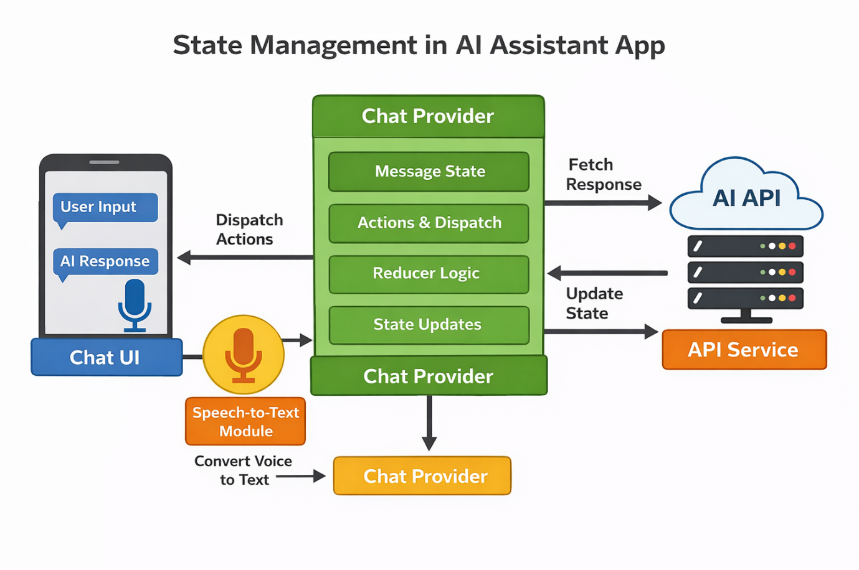

UI SCREENS

Splash Screen New Account Creation
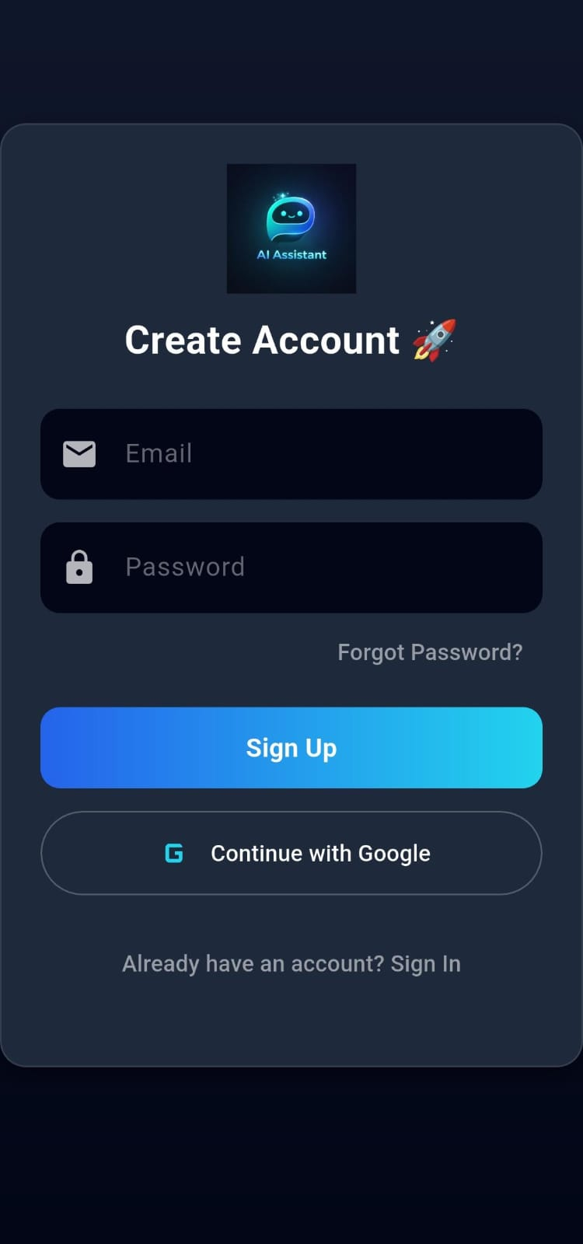


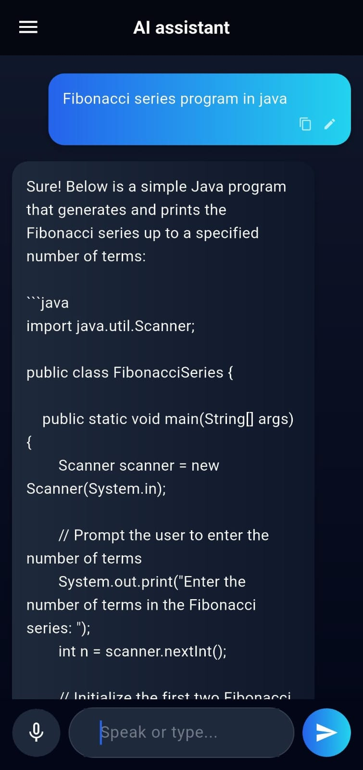
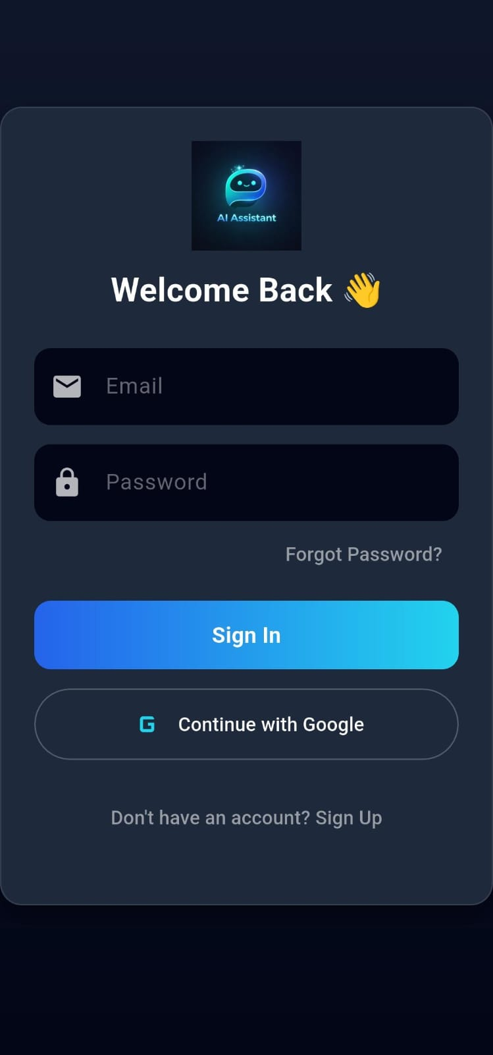
Sign In screen Chat with AI

Chat History Rename & Delete Chat
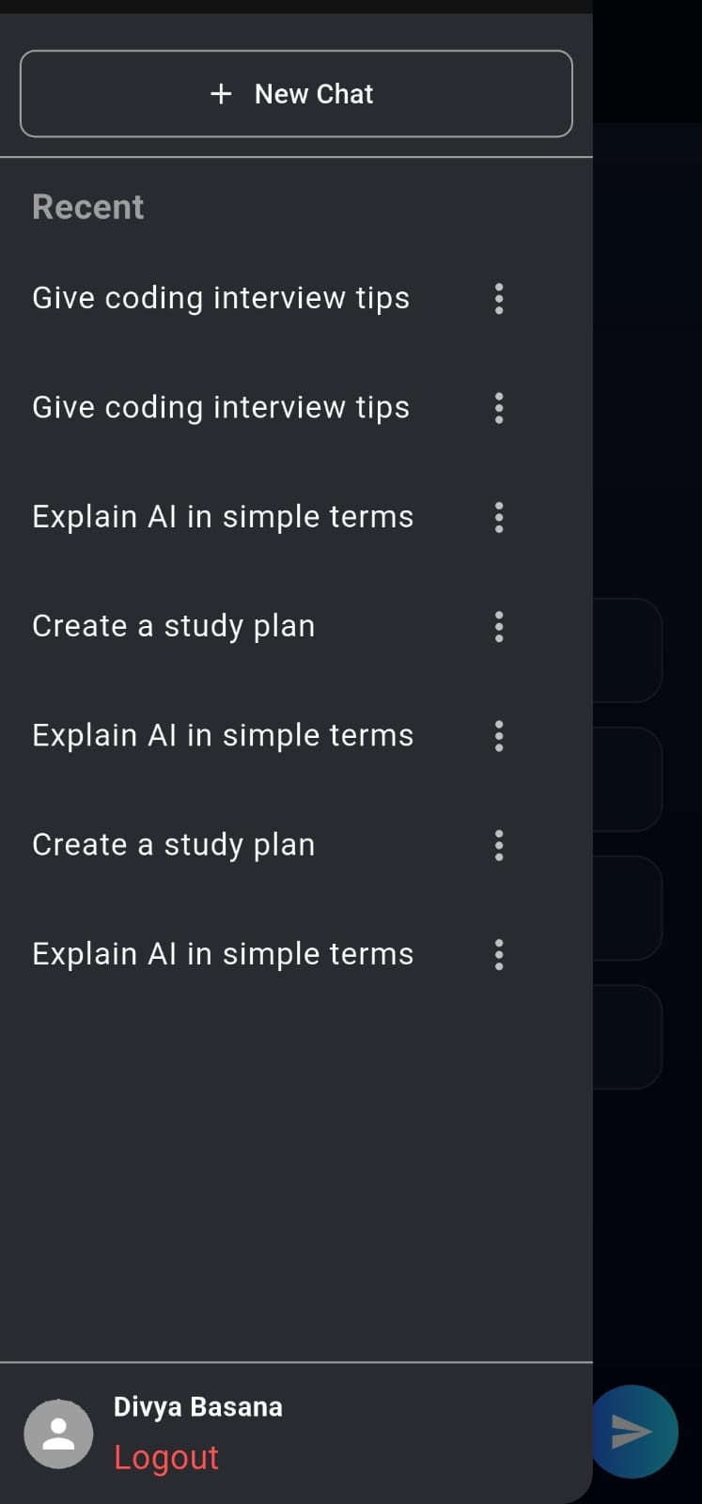
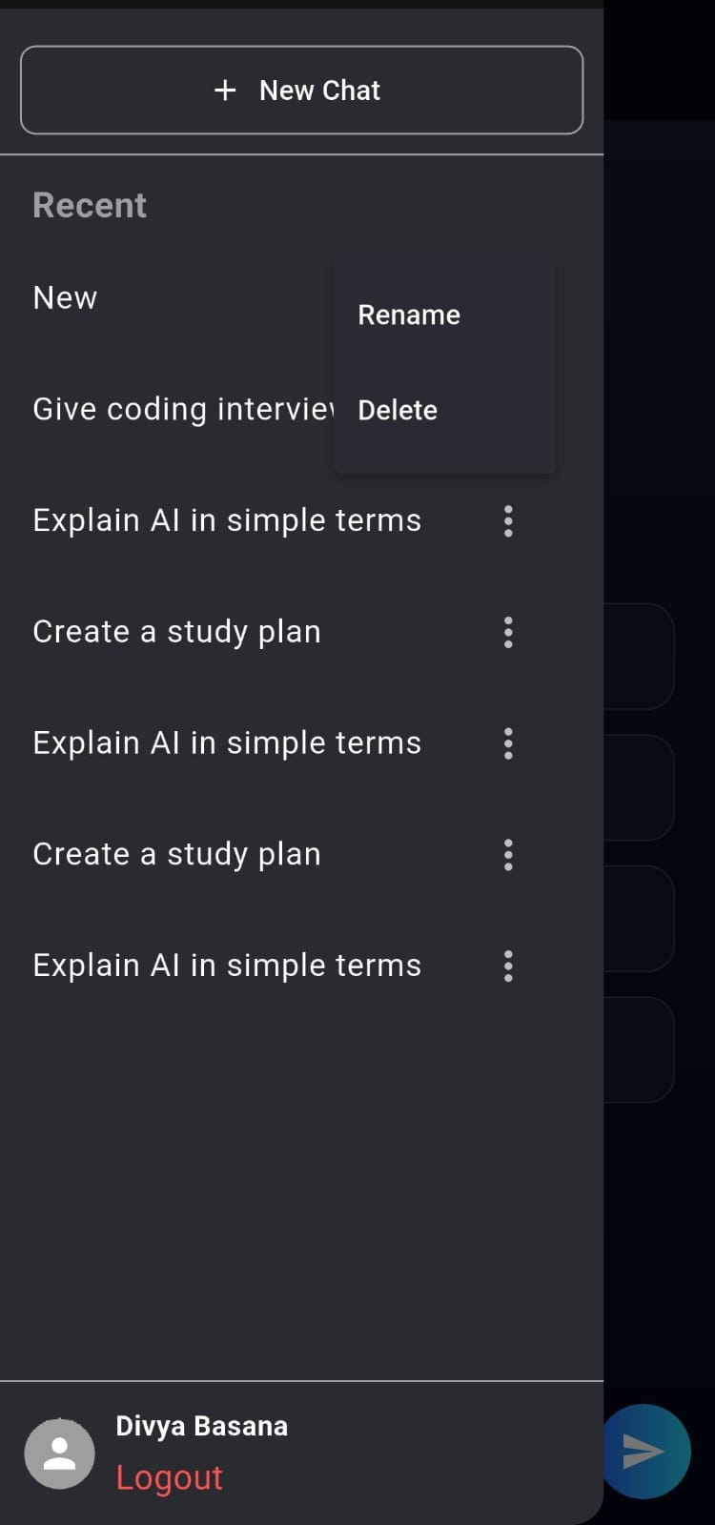

Edit the user prompt Voice Input
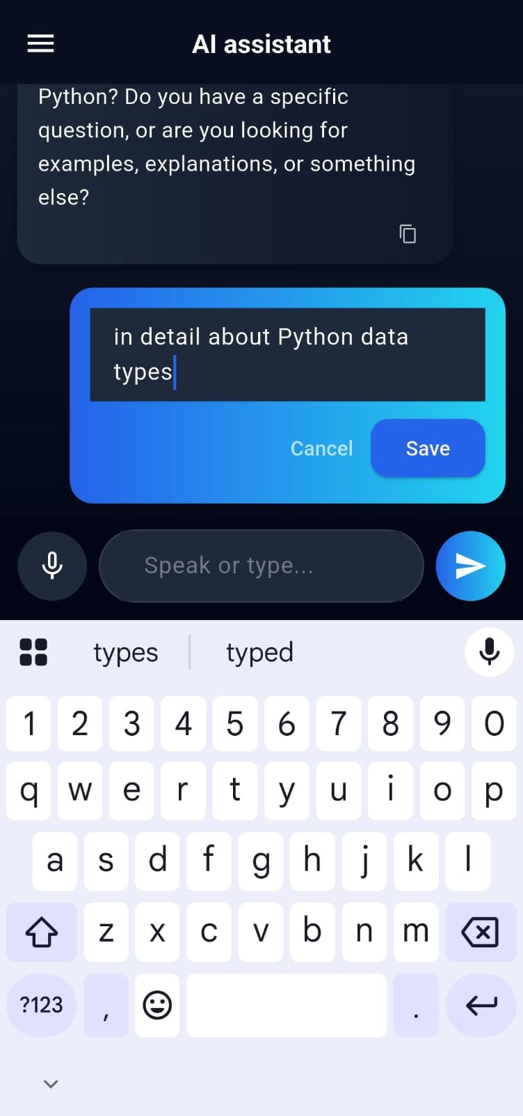
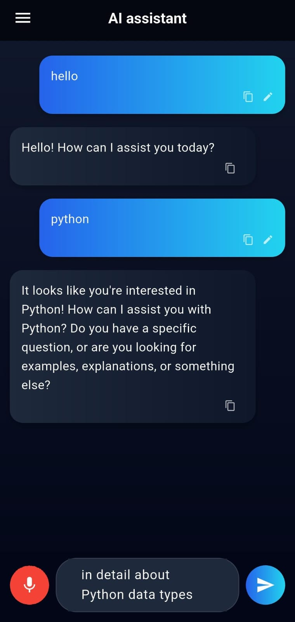

Forget Password Rest Link to mail
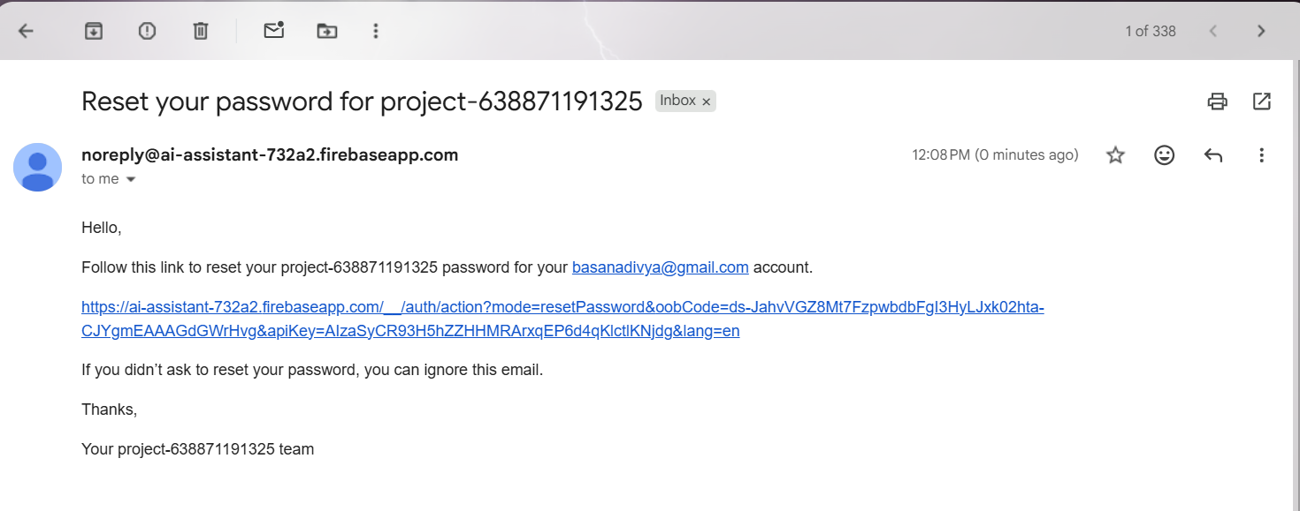


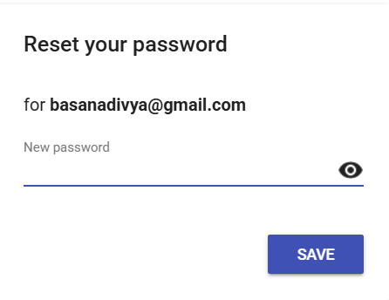
Reset Password Password changed

Firebase - Backend
Firebase is a cloud-based backend platform developed by Google that provides tools and services for building scalable and secure applications.
In this project, Firebase is used to handle user authentication and backend support. It enables users to register and log in securely using email and password. Firebase manages user sessions, ensuring that authentication state is maintained even after restarting the application.
The integration of Firebase simplifies backend development by eliminating the need for a custom server and provides reliable, real-time services. It also ensures data security, scalability, and seamless user management.
Firebase Console

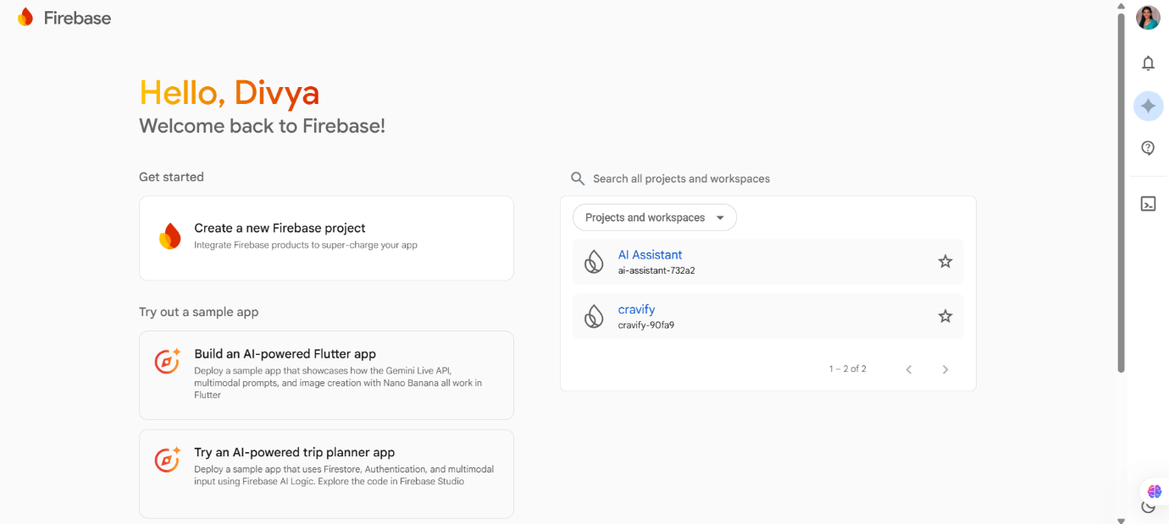
Project Overview
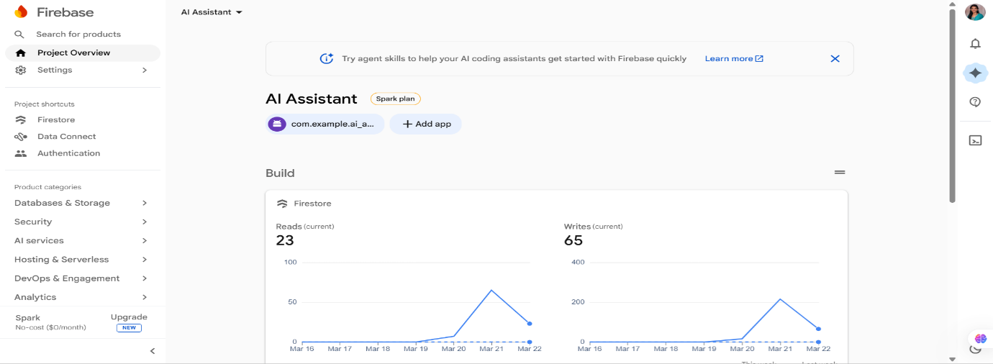

Firebase Authentication
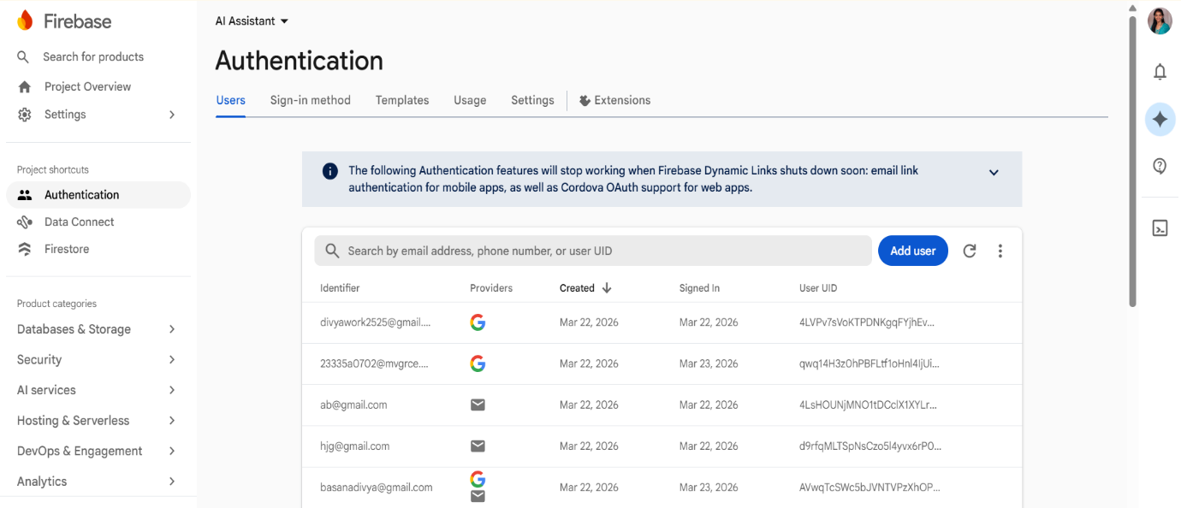

Firestore Data
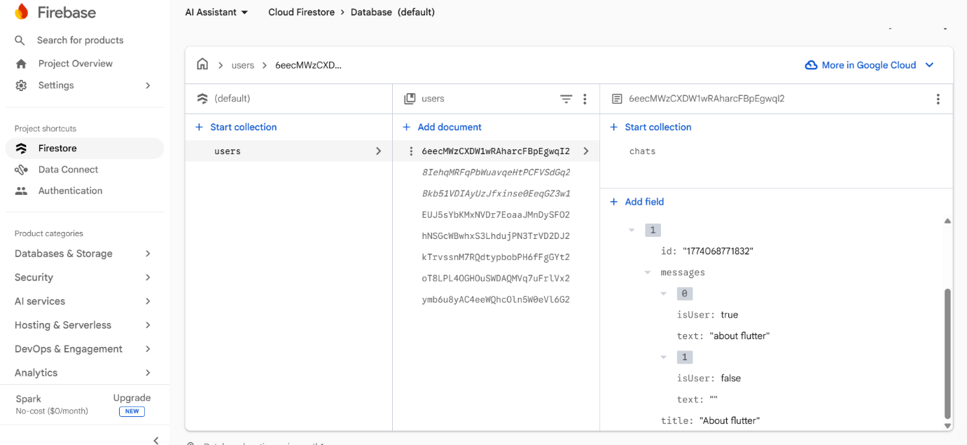

CONCLUSION

The AI Assistant mobile application successfully demonstrates the integration of artificial intelligence, mobile development, and voice-enabled interaction to provide an intelligent and user-friendly system. The application allows users to interact through both text and voice input, making the experience more natural, accessible, and efficient.
Developed using Flutter, the app follows a modular layered architecture that includes presentation, state management, service, and data layers, ensuring scalability and maintainability. The use of Provider enables efficient state management and smooth UI updates, while API integration facilitates real-time intelligent responses. Firebase authentication ensures secure user access and session management.
The addition of the voice (mic) feature enhances the overall functionality by enabling speech-to-text interaction, reducing dependency on manual typing and improving usability. Overall, the project meets its objective of creating a smart, responsive, and scalable AI assistant application, while also providing a strong foundation for future enhancements such as multilingual support, voice responses, and personalized user experiences.

